**National University of Computer and Emerging Sciences**



**Laboratory Tasks 06**

*for*

# Web Engineering

*Instructor: Saqib Ameer*

*Email: saqib.ameer@nu.edu.pk*

# Spring 2024

**FAST School of Computer Science**

**Queries for Mongo DB crud operations**

use e-comm

db.products.deleteOne({name:'ABC'})

db.products.updateOne({name:'ABC'},{$set:{branch:'oppo'}})

db.products.find({name:'ABC'})

db.products.insertOne({name:'ABC' , brand:'HJK' , price: 450 , category:'Mobiles'})

**These tasks from 1 to 3 you need to implement using express and nodejs**

**In these tasks make one public folder in which save the files index.html and style.css and one server.js file in which make variable sand app.get and app.post two functions.**

**Lab Task 1**:

Make a Login form using html and css for styling form response is handle through html req and res so you need to make this in nodejs using express.js as the server framework.

Output is that validate username and password like if username is saqib and password is 123 then form is submitted otherwise alert box show that username is not valid.

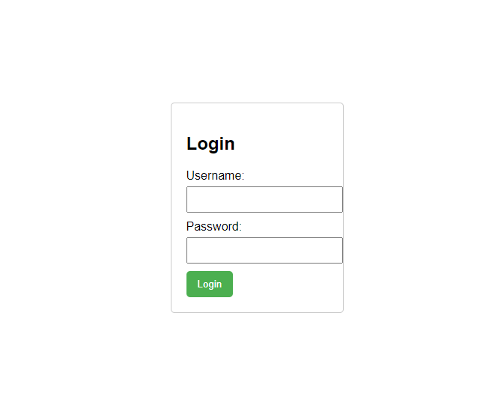

In this task if user enter the button login then next page display in which username is shown at top right side

Your task is to enter username password and emailid if email id username is in the list then user can be logged in and other check is password andf confirm password must be matched.

**Lab Task 2**:

**Lab Task 10:**

Make a simple BMI (Body Mass Index) calculator using HTML for the frontend, CSS for styling, and Node.js for the server. Use Express.js as the server framework and EJS as the template engine. Files required index.ejs style.css server.js package.json

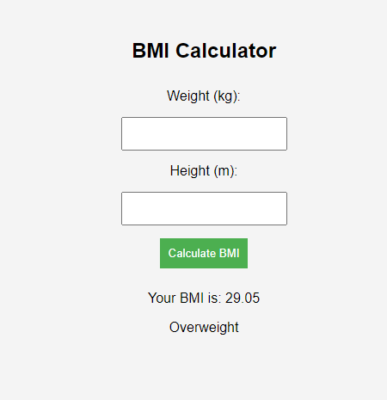

**Your task is to make this system based on the checks given**

**In this you need to implement using boostrap but the output is given below.**

**Lab Task 3**:

**You need to develop a system using html css and nodejs use the ejs as a template engine and express as a framework system in which you enter the number of passengers and perperson fare also write the name of the city then system automatically calculated your fare based on the 10% discount on 5 no of passengers and 15% discount on 7 Number of passengers and 30% discount on travelling from LAHORE to FSD.**

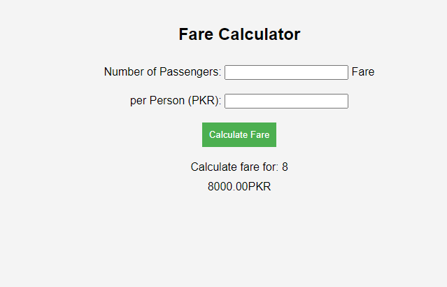

**Lab Task 4**:

**Explore and configure the Mongodb and create account on mongodb atlas and gui tool compass**

**Lab Task 5**:

Simple run Crud queries on mongodb compass mangosh

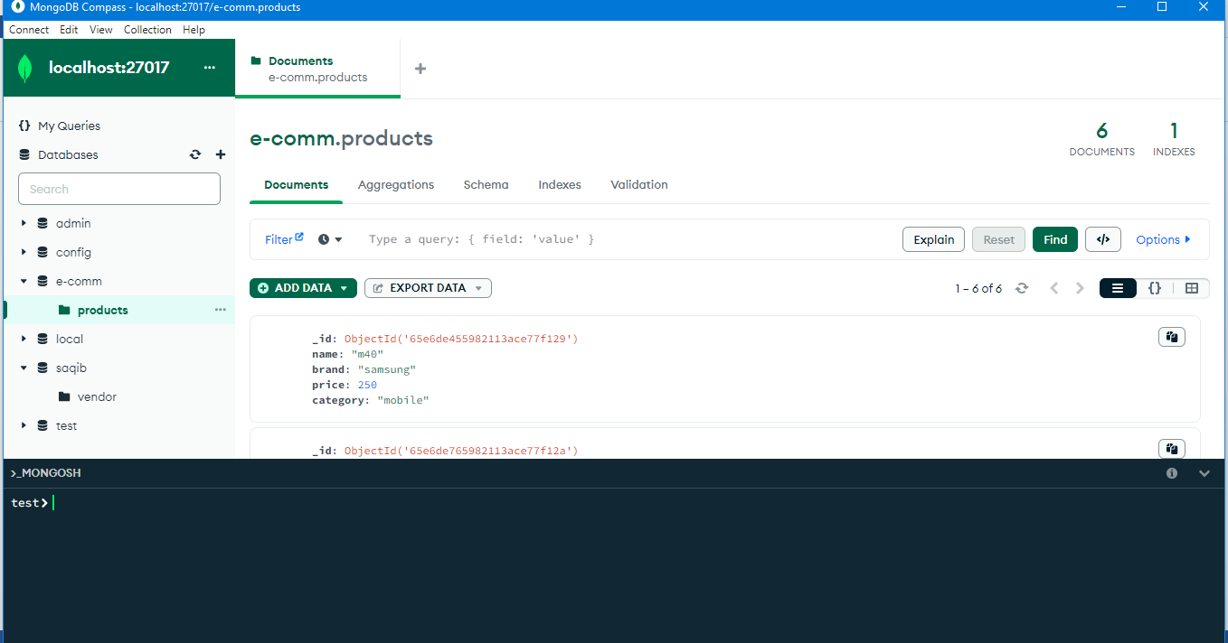

**Lab Task 6**:

Make the Connection of Mongodb localhost in nodejs

**Lab Task 7**:

Make a Crud system using nodejs and mongodb in which make 4 different files insert.js update.js delete.js view.js and connect.js (is like a package)

You need to perform all these operations and record is successfully modified on compass mongodb

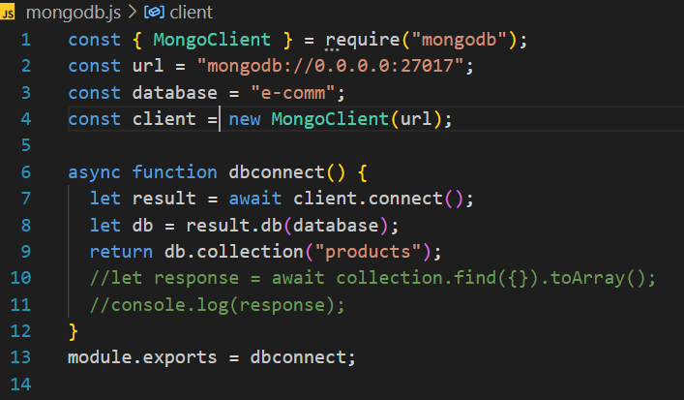

**You are done with your exercise(s), make your submission on Classroom.**

**BEST WISHES**